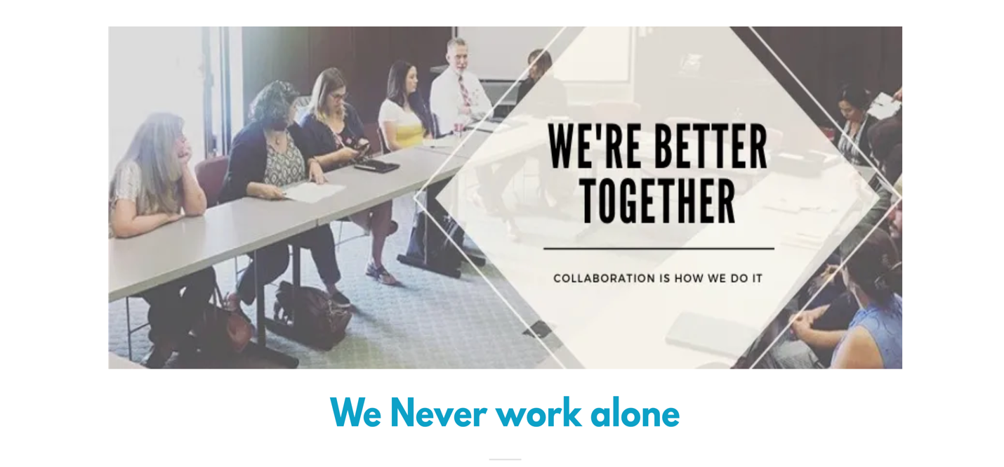
About Us
- We are a collection of congregations in Fullerton that sincerely believe we must work together as the church of the city to accomplish His will in our city. We have gathered together over the years under different names and banners but we have always believed the church United is a force for good.
- Fullerton ACT was the most recent banner that pulled us together. This movement really gained momentum after the murder of Thomas Kelly in July of 2011. The community knew it had to respond in a way that mobilized people of faith to address the homelessness crisis in the city. Jason Phillips stepped up and provided excellent leadership for close to 12 years. We are grateful.
- Unite Fullerton is the newest expression we are gathering under. We will continue with the general mission and vision that we forged together under Fullerton Act but with some renewed energy and focus.
- Our Leadership team consists of Mark Speeter, pastor of Antioch Community church here in Fullerton. Mark has been the Lead Pastor of this community for 6 years now and he has always valued partnerships with his fellow city pastors. Bryan Maxwell, Associate Pastor at Wilshire Ave church is our longest tenured leader on the team. He has been in the city leading for over 20 years now and deeply values relationships and community engagement. Jay Williams, the founder and president of OC United, previously he served as Pastor of Compassion and Justice at the Fullerton Free church for 16 years. He is focused on mobilizing the church of the city to care about our most vulnerable communities so that everyone can flourish.
- Our Mission is to inspire, empower, and align the church in addressing our city’s spiritual, relational and practical challenges.

Our Initiatives

