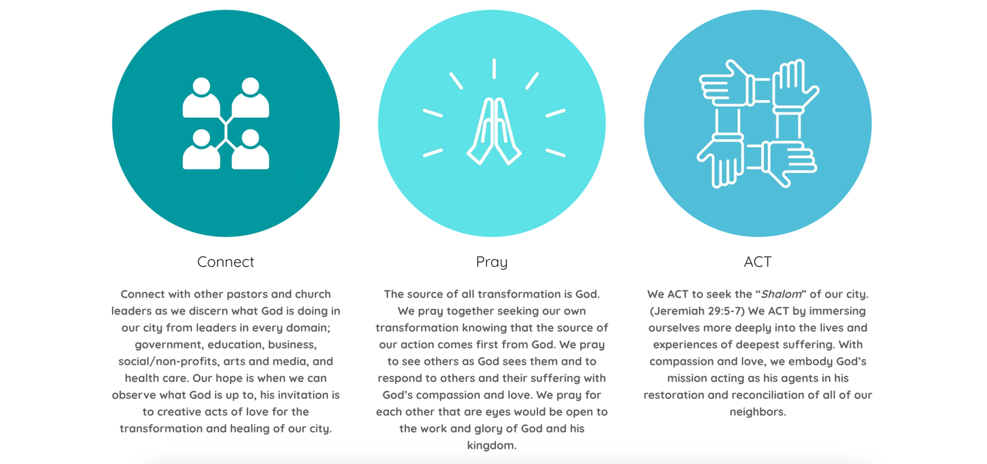

Our Initiatives
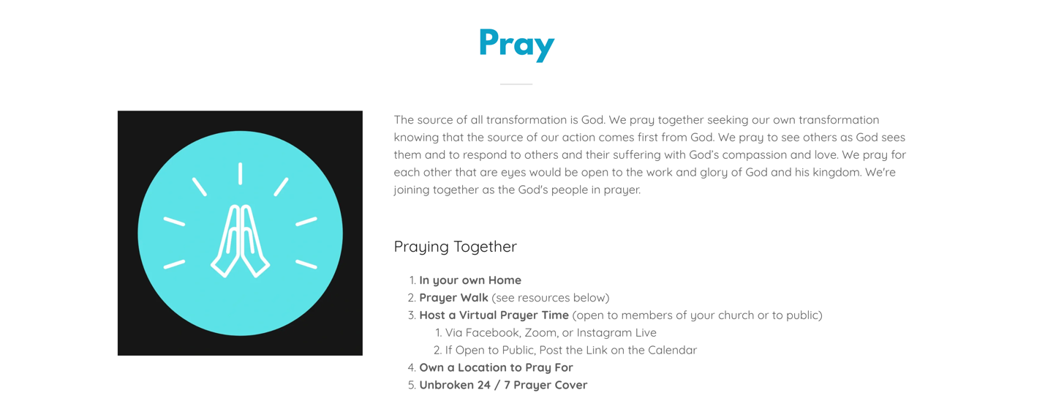
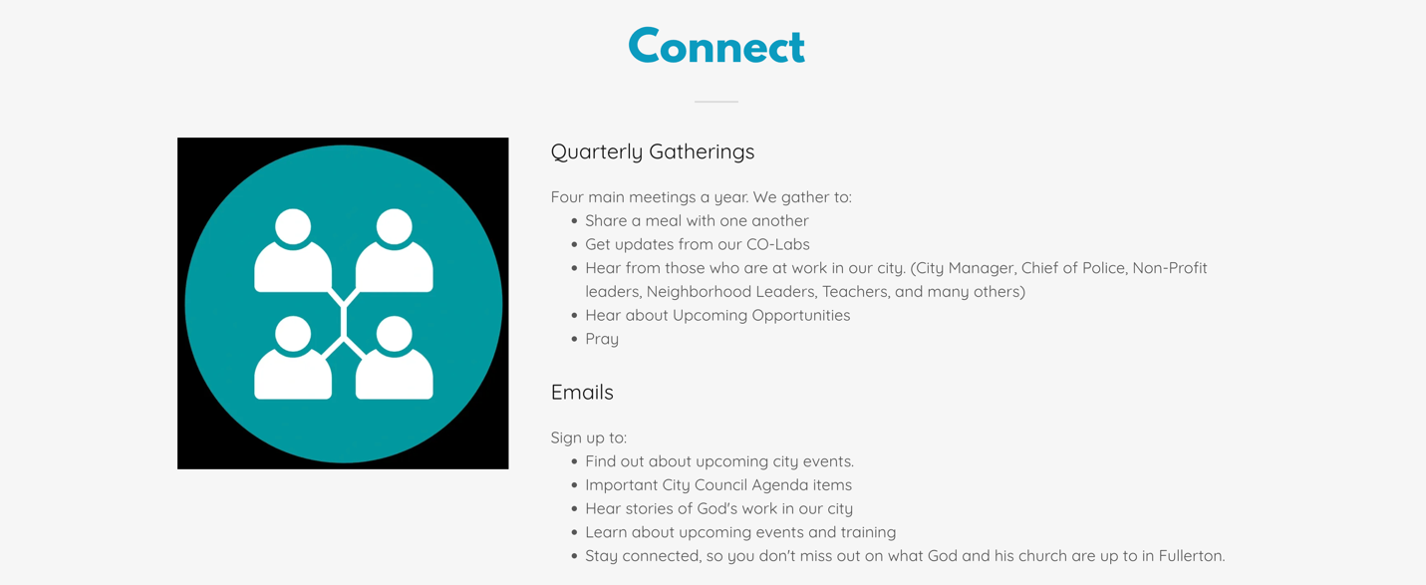
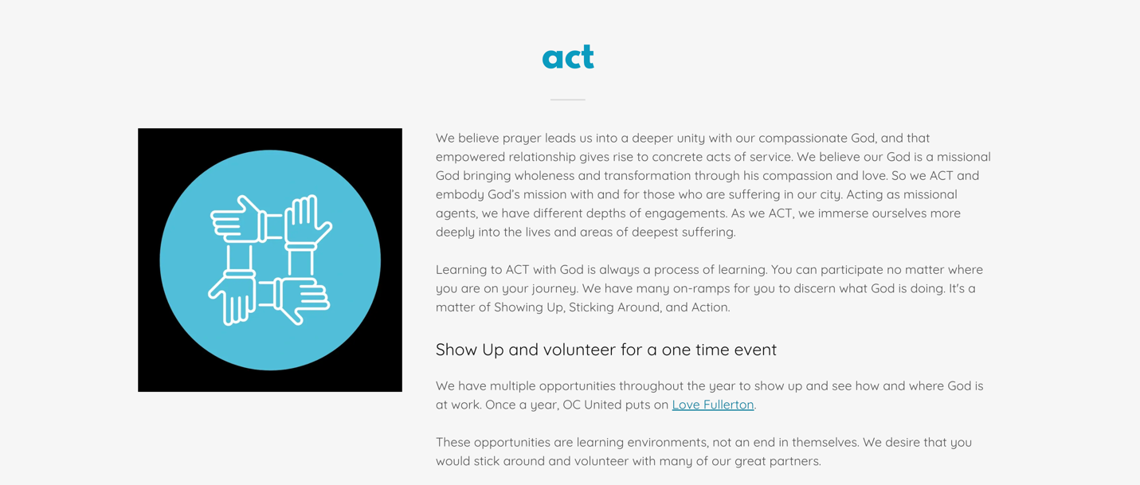

- Love Every School:
Overview - To mobilize communities of faith to support the well-being of every student in every school. Our dream is to see communities of faith partnering with every school in our district. The partnership will provide clear goals and next steps for congregations entering into this strategic roles. The Colab leader is responsible to shepherd this movement forward and lead the core team
Desired Outcome - Success in this role is moving closer towards the goal of every school has a faith community partner that is actively engaged in clear and meaningful participation with their partner schools. Each partnership will look different but this leader will provide guidance and accountability that clear levels of engagement derived from best practices will be provided. The leader will also develop a cross congregational team that meets monthly to direct the progress.

Interested in learning how to partner with one of our FSD schools, email: Bryan@wilshireave.com to get started.

- Love the Unhoused
Overview:

Desired Outcome:

Interested in learning what it means to be your congregations Love the Unhoused Liaison contact Mikec@ocunited.org to get started.

- Love our Neighbors
Overview:

Desired Outcome

Interested in learning what it means to be part of a city-wide plan to build neighborhood connectors contact jayw@ocunited.org to get started.

